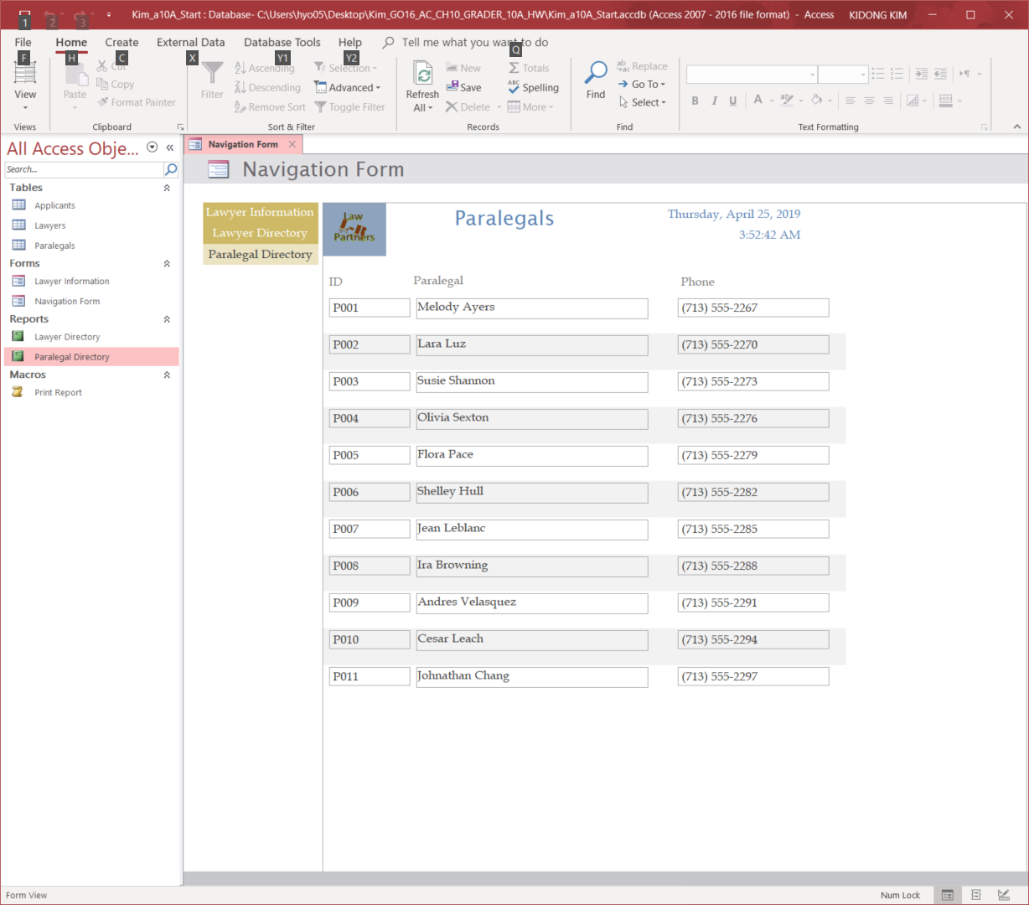

**Project 10A Activity 10.02 Step 8**

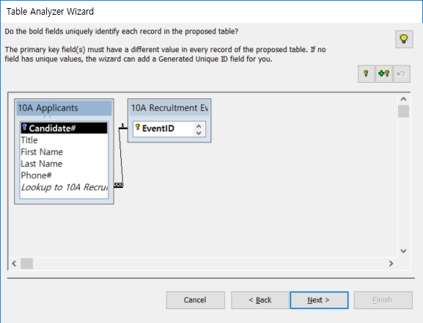

**Project 10A Activity 10.03 Step 9**

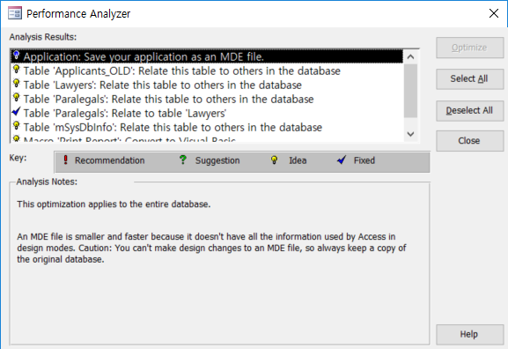

**Project 10A Activity 10.06 Step 5**

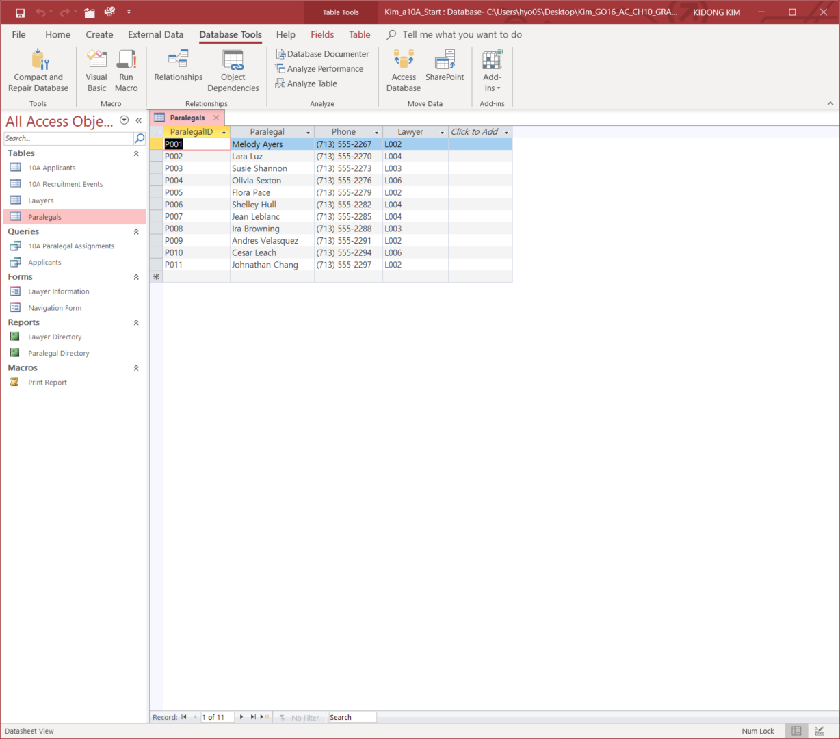

**Project 10A Activity 10.08 Step 12**

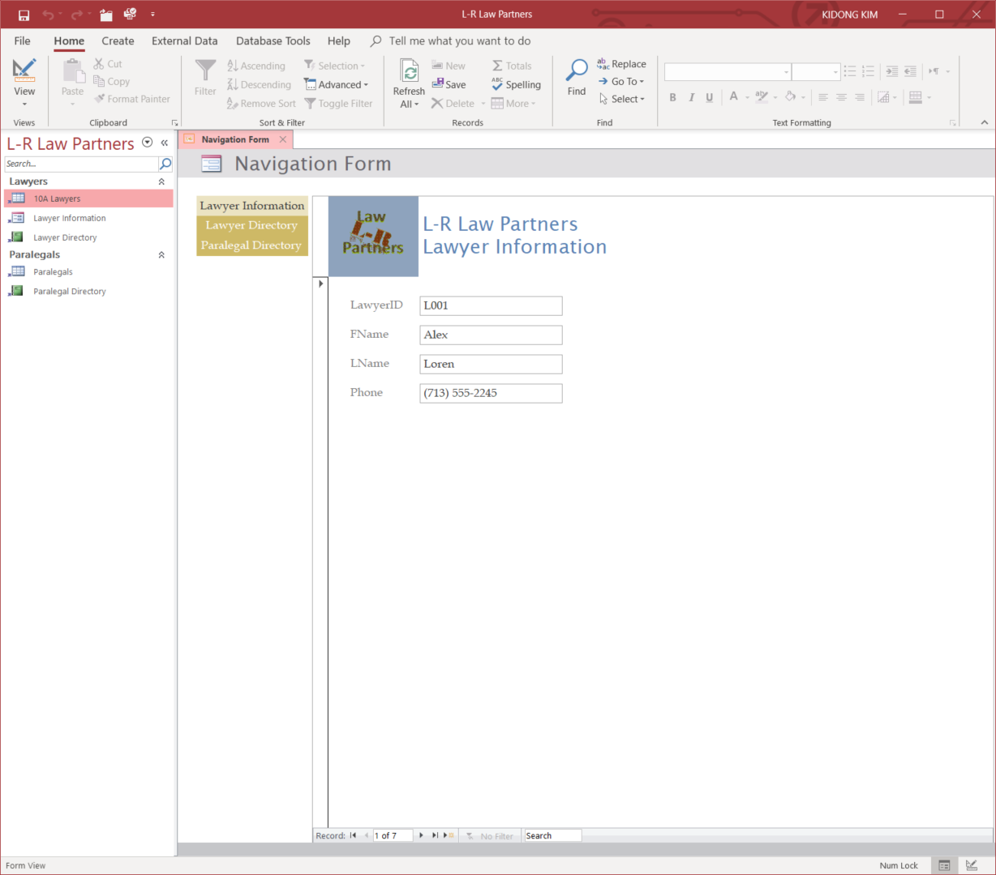

**Project 10A Activity 10.09 Step 5**

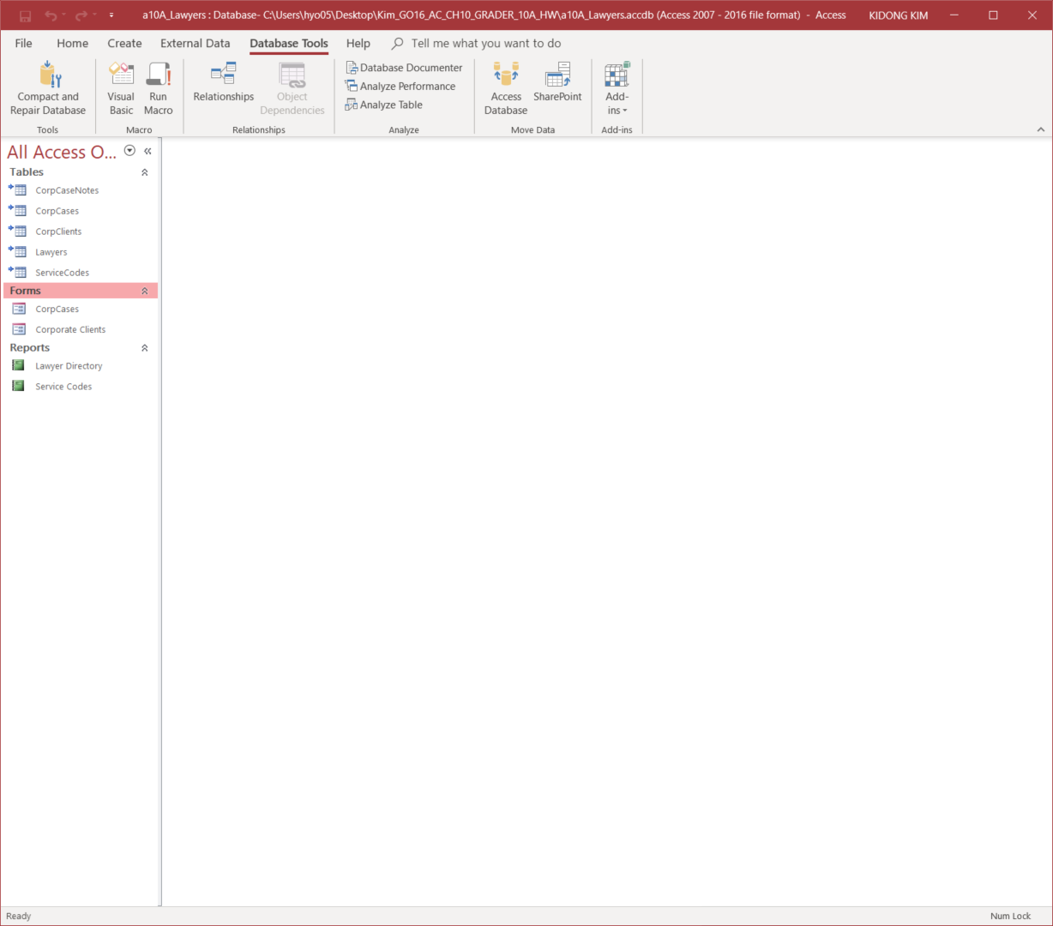

**Project 10A Activity 10.12 Step 10**

